**📰 Test Suite 1 – inews (Mobile, Politics page)**

**Setup**

1. Open **Chrome → New Incognito** (Cmd + Shift + N).
2. Open **DevTools** (Cmd + Option + I).
3. Go to **Network tab**.
   * Tick **Preserve log**.
   * Tick **Disable cache**.
   * In the filter bar, type: g/collect.
4. Turn on **mobile view** (Cmd + Shift + M).
   * Select **Pixel 5** (top dropdown).
5. Set **UK location**:
   * DevTools menu (⋮) → **More tools → Sensors**.
   * Location: **Other…** → Latitude = 51.5074, Longitude = -0.1278.
   * Locale = en-GB.
6. Clear storage: DevTools → **Application tab → Storage → Clear site data**.

**Test Steps**

1. Go to https://inews.co.uk/category/news/politics.
2. In **Network**, find the first GA request with en=page_view.
   * Check parameters:
     + ep.sub_channel_1 = news/politics
     + gcs = G101
     + npa = 1
   * Take screenshot.

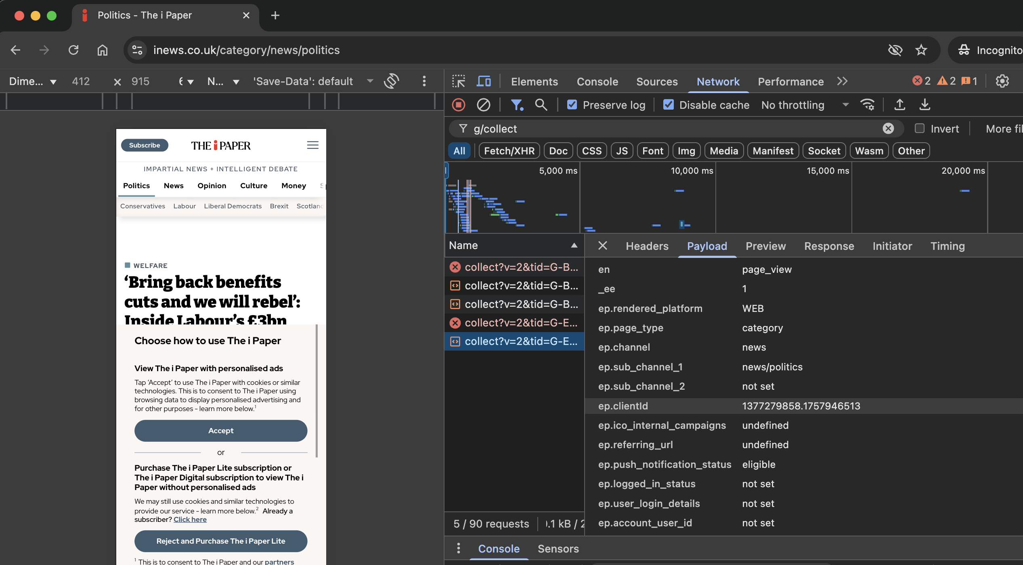

1. On the page, click **Accept** in the cookie banner.
   * Confirm banner is gone (check DOM in Elements tab or visually). Screenshot.

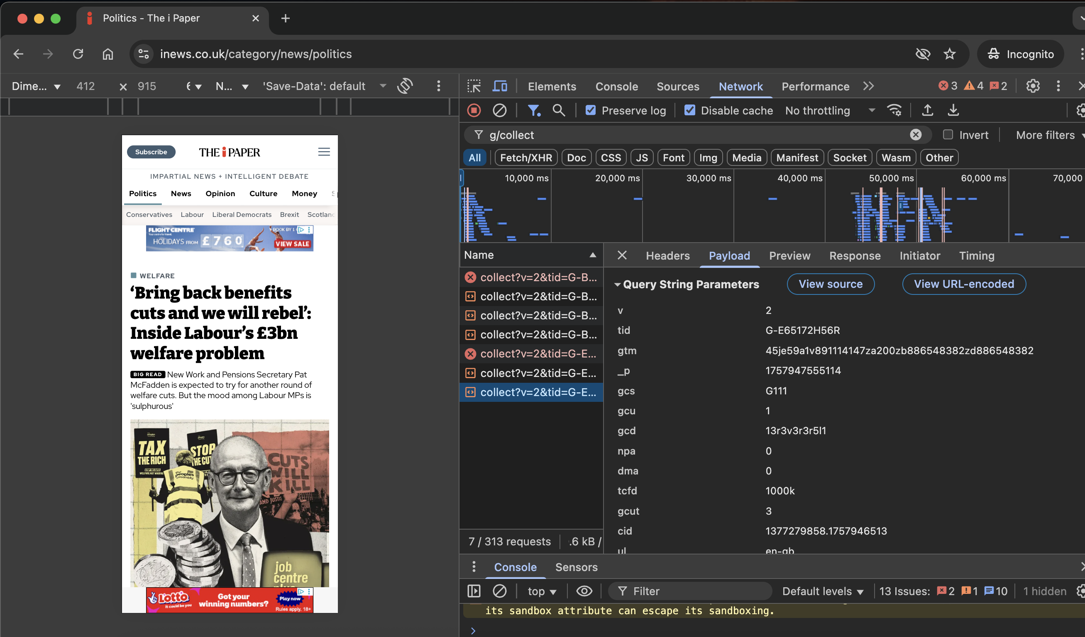

1. Back in **Network**, find next GA request with en=user_engagement.
   * Check parameters:
     + gcs = G111
     + npa = 0 **or missing**
   * Take screenshot.

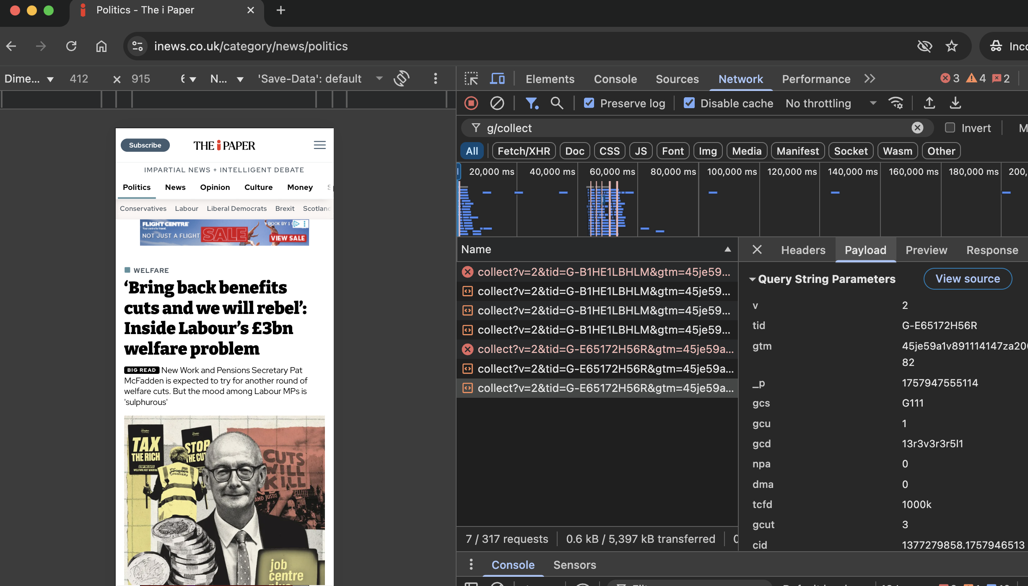

**🔬 Test Suite 2 – New Scientist (Desktop, Dark Mode)**

**Setup**

1. Open new **Incognito** window.
2. Open **DevTools** (Cmd + Option + I).
3. Force Dark Mode:
   * Press Cmd + Shift + P (command menu).
   * Type **Rendering** → click **Show Rendering**.
   * In Rendering panel (bottom), set **Emulate CSS prefers-color-scheme: Dark**.
4. Clear storage: DevTools → **Application → Storage → Clear site data**.

**Test Steps**

1. Go to https://www.newscientist.com/.
2. After page loads, check <html> tag in **Elements** tab.
   * Should contain class Dark. Screenshot.

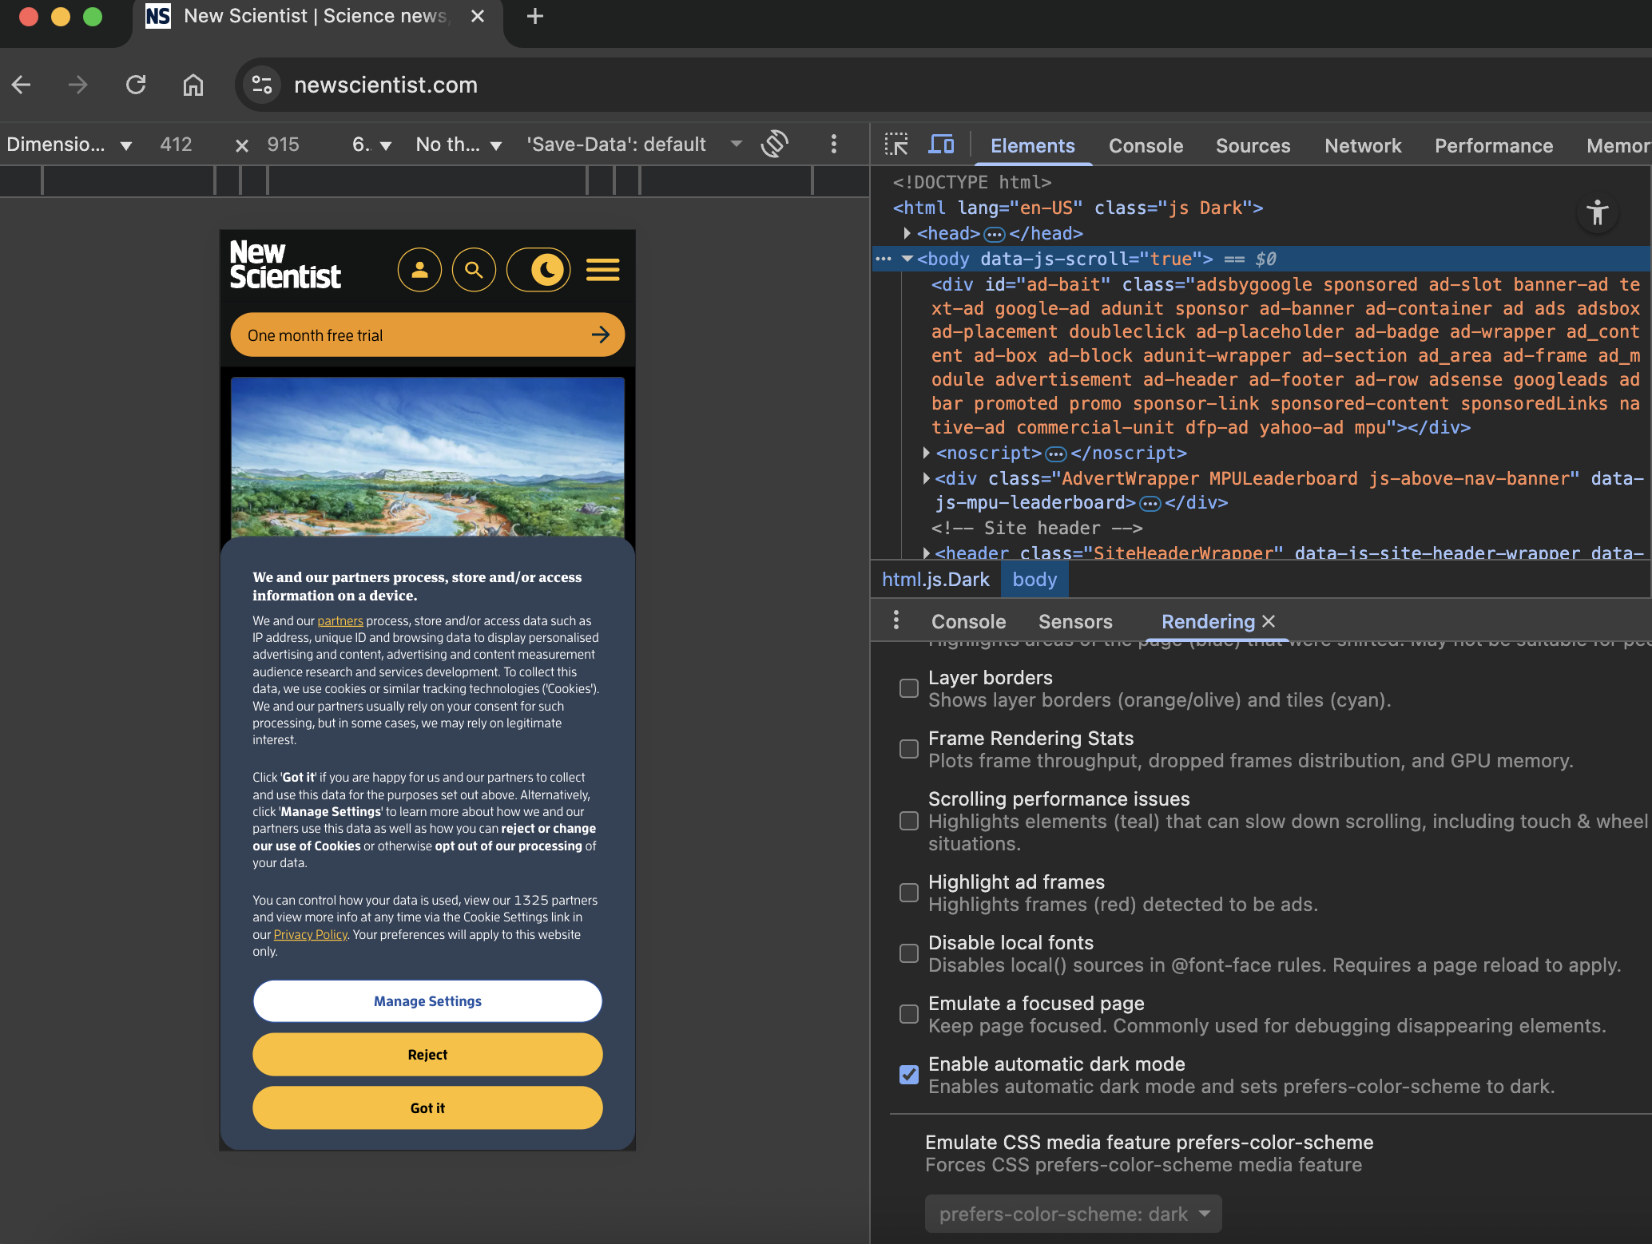

1. In **Application → Local Storage** for www.newscientist.com:
   * Key colourSchemeAppearance = Dark. Screenshot.

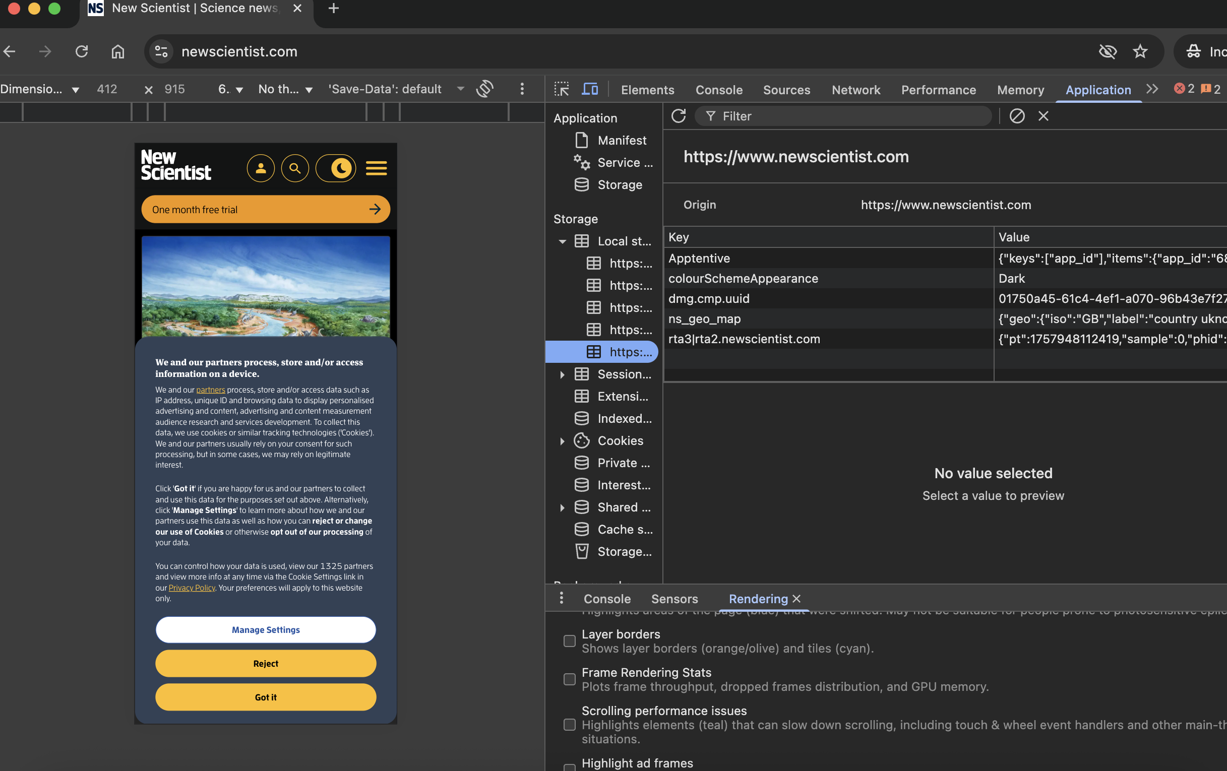

1. On the site, click **Got It** button in the cookie banner.
   * Confirm banner gone. Screenshot.

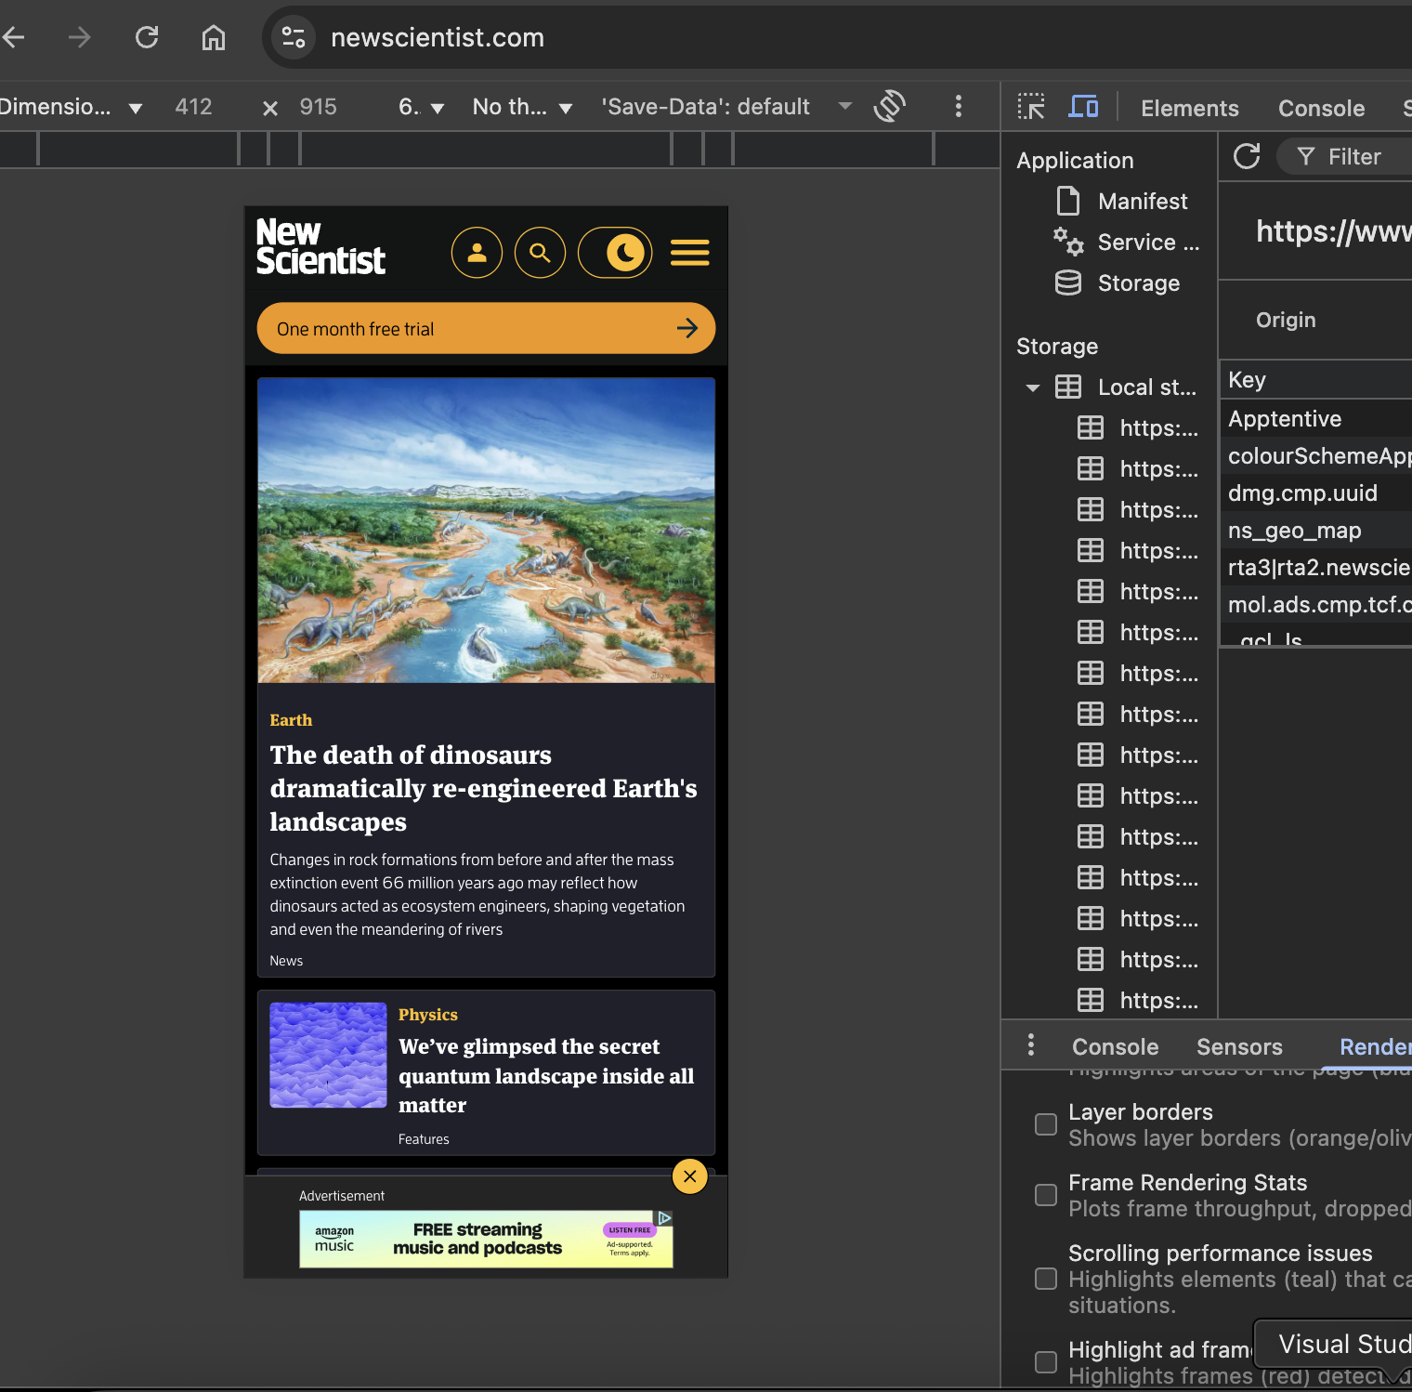

1. Click the **Appearance toggle (#appearance-toggle)**.
2. Check <html> tag again:
   * Should now have Light (and no Dark). Screenshot.

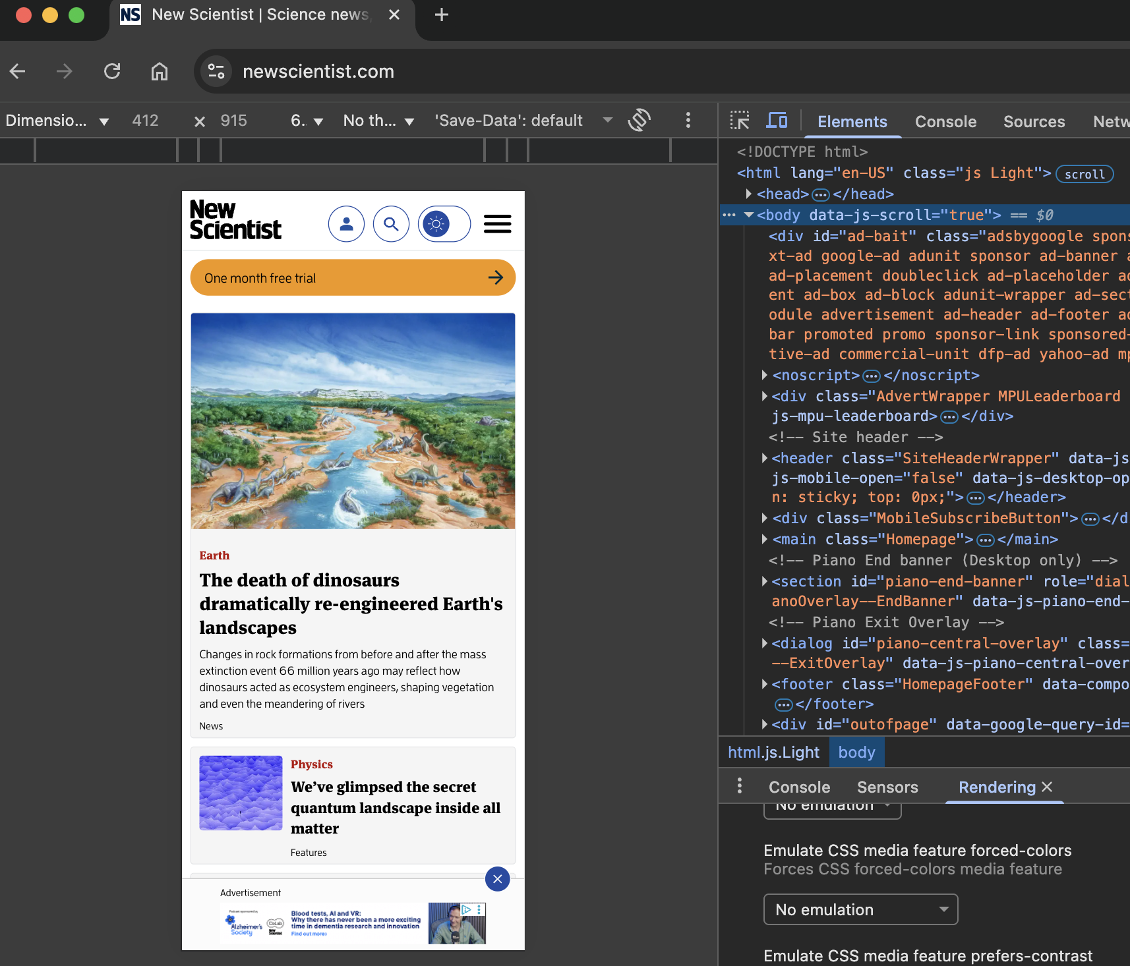

1. Check Local Storage again:
   * colourSchemeAppearance = Light. Screenshot.

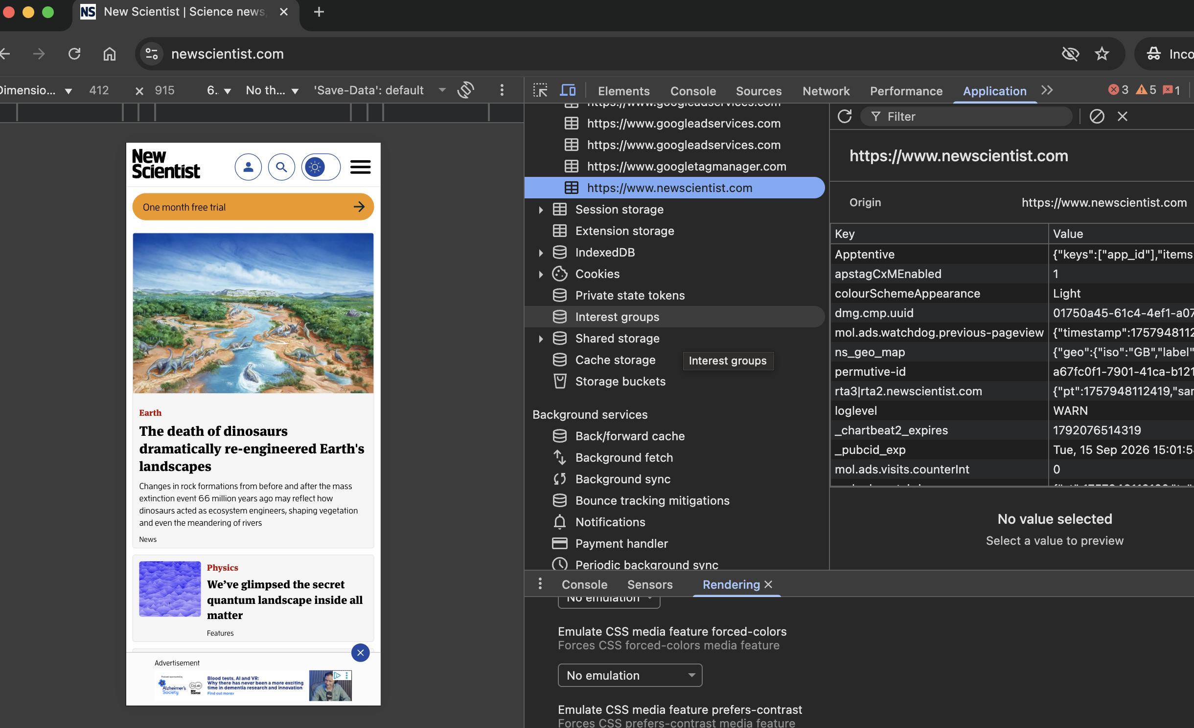

1. Refresh page (Cmd + R).
   * <html> still has Light. Screenshot.

